**[연습문제]**

1. 안드로이드 컴포넌트 중, ( 1 )는 애플리케이션 사이에 데이터를 상호 공유하기 위한 용도로, ( 2 )는 여러 응용프로그램이나 장치에게 메시지를 전달하기 위한 용도로, ( 3 )는 백그라운드에서 작동하기 위한 용도로, ( 4 )는 화면을 구성하는 용도로 사용된다.

2. 명시적 인텐트에서 데이터를 전달할 때, 메인 액티비티에서 ( 1 ) 메소드로 인텐트에 데이터를 넣고, ( 2 ) 메소드로 서브 액티비티로 인텐트를 넘긴다.

그리고, 서브 액티비티에서는 ( 3 ), ( 4 ), ( 5 ) 등의 메소드로 받은 데이터에 접근한다.

3. 양방향 액티비티에서 메인 액티비티에서는 ( 1 ) 메소드로 서브 액티비티를 호출하고, 서브 액티비티에서는 ( 2 ) 메소드로 결과를 돌려준다.

4. 정상적으로 액티비티가 시작되고, 종료될 때 호출되는 Activity 클래스의 메소드를 차례대로 써라.

5. <실습 10-1>을 개선해서 다음 그림과 같이 작동하도록 프로젝트를 작성하라.

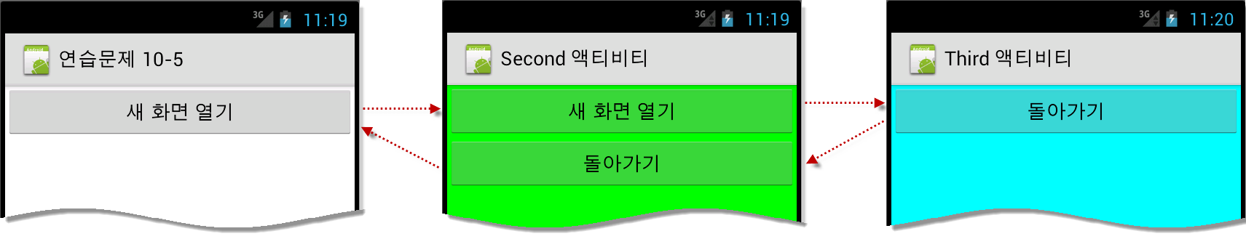

6. <실습 10-2>를 개선해서 결과화면이 뷰플리퍼로 1등부터 1초마다 자동으로 나오도록 프로젝트를 작성하라.

힌트 : 뷰플리퍼는 6장에서 다뤘다.

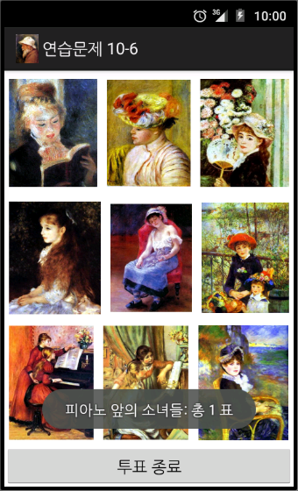 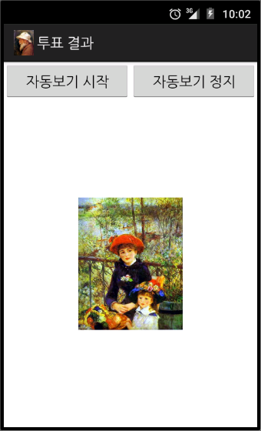

**[연습문제-답안]**

1.

(1) 콘텐트 프로바이더

(2) 브로드캐스트 리시버

(3) 서비스

(4) 액티비티

2. (1) putExtra()

(2) startActivity()

(3) ~ (5) getStringExtra(), getIntExtra(), getBooleanExtra()

3. (1) startActivityforResult()

(2) setResult()

4. onCreate(), onStart(), onResume() , onPause(), onStop(), onDestroy()

5.

*** activity_main.xml ***

<LinearLayout xmlns:android="http://schemas.android.com/apk/res/android"

android:layout_width="fill_parent"

android:layout_height="fill_parent"

android:orientation="vertical" >

<Button

android:id="@+id/btnNewActivity"

android:layout_width="match_parent"

android:layout_height="wrap_content"

android:text="새 화면 열기" />

</LinearLayout>

*** second.xml ***

<LinearLayout xmlns:android="http://schemas.android.com/apk/res/android"

android:layout_width="match_parent"

android:layout_height="match_parent"

android:background="#00FF00"

android:orientation="vertical" >

<Button

android:id="@+id/btnNewActivity"

android:layout_width="match_parent"

android:layout_height="wrap_content"

android:text="새 화면 열기" />

<Button

android:id="@+id/btnReturn"

android:layout_width="match_parent"

android:layout_height="wrap_content"

android:text="돌아가기" />

</LinearLayout>

*** third.xml ***

<LinearLayout xmlns:android="http://schemas.android.com/apk/res/android"

android:layout_width="match_parent"

android:layout_height="match_parent"

android:background="#00FFFF"

android:orientation="vertical" >

<Button

android:id="@+id/btnReturn"

android:layout_width="match_parent"

android:layout_height="wrap_content"

android:text="돌아가기" />

</LinearLayout>

*** 메인 Java ***

package com.cookandroid.exercise10_5;

import android.app.Activity;

import android.content.Intent;

import android.os.Bundle;

import android.view.View;

import android.widget.Button;

public class MainActivity extends Activity {

@Override

public void onCreate(Bundle savedInstanceState) {

super.onCreate(savedInstanceState);

setContentView(R.layout.activity_main);

setTitle("연습문제 10-5");

Button btnNewActivity = (Button) findViewById(R.id.btnNewActivity);

btnNewActivity.setOnClickListener(new View.OnClickListener() {

public void onClick(View v) {

Intent intent;

intent = new Intent(getApplicationContext(),

SecondActivity.class);

startActivity(intent);

}

});

}

}

*** SecondActivity.java ***

package com.cookandroid.exercise10_5;

import android.app.Activity;

import android.content.Intent;

import android.os.Bundle;

import android.view.View;

import android.widget.Button;

public class SecondActivity extends Activity {

@Override

protected void onCreate(Bundle savedInstanceState) {

// TODO Auto-generated method stub

super.onCreate(savedInstanceState);

setContentView(R.layout.second);

Button btnNewActivity = (Button) findViewById(R.id.btnNewActivity);

btnNewActivity.setOnClickListener(new View.OnClickListener() {

public void onClick(View v) {

Intent intent;

intent = new Intent(getApplicationContext(),

ThirdActivity.class);

startActivity(intent);

}

});

Button btnReturn = (Button) findViewById(R.id.btnReturn);

btnReturn.setOnClickListener(new View.OnClickListener() {

public void onClick(View v) {

finish();

}

});

}

}

*** ThirdActivity.java ***

package com.cookandroid.exercise10_5;

import android.app.Activity;

import android.os.Bundle;

import android.view.View;

import android.widget.Button;

public class ThirdActivity extends Activity {

@Override

protected void onCreate(Bundle savedInstanceState) {

// TODO Auto-generated method stub

super.onCreate(savedInstanceState);

setContentView(R.layout.third);

Button btnReturn = (Button) findViewById(R.id.btnReturn);

btnReturn.setOnClickListener(new View.OnClickListener() {

public void onClick(View v) {

finish();

}

});

}

}

** AndroidManifest.xml **

<?xml version="1.0" encoding="utf-8"?>

<manifest xmlns:android="http://schemas.android.com/apk/res/android"

package="com.cookandroid.exercise10_5"

android:versionCode="1"

android:versionName="1.0" >

<uses-sdk

android:minSdkVersion="16"

android:targetSdkVersion="21" />

<application

android:allowBackup="true"

android:icon="@drawable/ic_launcher"

android:label="@string/app_name"

android:theme="@style/AppTheme" >

<activity

android:name=".MainActivity"

android:label="@string/app_name" >

<intent-filter>

<action android:name="android.intent.action.MAIN" />

<category android:name="android.intent.category.LAUNCHER" />

</intent-filter>

</activity>

<activity

android:name=".SecondActivity"

android:label="Second 액티비티" />

<activity

android:name=".ThirdActivity"

android:label="Third 액티비티" />

</application>

</manifest>

6.

*** activity_main.xml ***

<LinearLayout xmlns:android="http://schemas.android.com/apk/res/android"

android:layout_width="fill_parent"

android:layout_height="fill_parent"

android:orientation="vertical" >

<LinearLayout

android:layout_width="match_parent"

android:layout_height="0dp"

android:layout_weight="3" >

<ImageView

android:id="@+id/iv1"

android:layout_width="wrap_content"

android:layout_height="wrap_content"

android:layout_margin="5dp"

android:layout_weight="1"

android:src="@drawable/pic1" />

<ImageView

android:id="@+id/iv2"

android:layout_width="wrap_content"

android:layout_height="wrap_content"

android:layout_margin="5dp"

android:layout_weight="1"

android:src="@drawable/pic2" />

<ImageView

android:id="@+id/iv3"

android:layout_width="wrap_content"

android:layout_height="wrap_content"

android:layout_margin="5dp"

android:layout_weight="1"

android:src="@drawable/pic3" />

</LinearLayout>

<LinearLayout

android:layout_width="match_parent"

android:layout_height="0dp"

android:layout_weight="3" >

<ImageView

android:id="@+id/iv4"

android:layout_width="wrap_content"

android:layout_height="wrap_content"

android:layout_margin="5dp"

android:layout_weight="1"

android:src="@drawable/pic4" />

<ImageView

android:id="@+id/iv5"

android:layout_width="wrap_content"

android:layout_height="wrap_content"

android:layout_margin="5dp"

android:layout_weight="1"

android:src="@drawable/pic5" />

<ImageView

android:id="@+id/iv6"

android:layout_width="wrap_content"

android:layout_height="wrap_content"

android:layout_margin="5dp"

android:layout_weight="1"

android:src="@drawable/pic6" />

</LinearLayout>

<LinearLayout

android:layout_width="match_parent"

android:layout_height="0dp"

android:layout_weight="3" >

<ImageView

android:id="@+id/iv7"

android:layout_width="wrap_content"

android:layout_height="wrap_content"

android:layout_margin="5dp"

android:layout_weight="1"

android:src="@drawable/pic7" />

<ImageView

android:id="@+id/iv8"

android:layout_width="wrap_content"

android:layout_height="wrap_content"

android:layout_margin="5dp"

android:layout_weight="1"

android:src="@drawable/pic8" />

<ImageView

android:id="@+id/iv9"

android:layout_width="wrap_content"

android:layout_height="wrap_content"

android:layout_margin="5dp"

android:layout_weight="1"

android:src="@drawable/pic9" />

</LinearLayout>

<Button

android:id="@+id/btnResult"

android:layout_width="match_parent"

android:layout_height="0dp"

android:layout_weight="1"

android:text="투표 종료" />

</LinearLayout>

*** result.xml ***

<LinearLayout xmlns:android="http://schemas.android.com/apk/res/android"

android:layout_width="match_parent"

android:layout_height="match_parent"

android:orientation="vertical" >

<LinearLayout

android:layout_width="match_parent"

android:layout_height="wrap_content"

android:orientation="horizontal" >

<Button

android:id="@+id/btnStart"

android:layout_width="wrap_content"

android:layout_height="wrap_content"

android:layout_weight="1"

android:text=" 자동보기 시작 " />

<Button

android:id="@+id/btnStop"

android:layout_width="wrap_content"

android:layout_height="wrap_content"

android:layout_weight="1"

android:text=" 자동보기 정지 " />

</LinearLayout>

<ViewFlipper

android:id="@+id/viewFlipper1"

android:layout_width="match_parent"

android:layout_height="match_parent" >

<ImageView

android:id="@+id/iv1"

android:layout_width="wrap_content"

android:layout_height="wrap_content"

android:layout_gravity="center" />

<ImageView

android:id="@+id/iv2"

android:layout_width="wrap_content"

android:layout_height="wrap_content"

android:layout_gravity="center" />

<ImageView

android:id="@+id/iv3"

android:layout_width="wrap_content"

android:layout_height="wrap_content"

android:layout_gravity="center" />

<ImageView

android:id="@+id/iv4"

android:layout_width="wrap_content"

android:layout_height="wrap_content"

android:layout_gravity="center" />

<ImageView

android:id="@+id/iv5"

android:layout_width="wrap_content"

android:layout_height="wrap_content"

android:layout_gravity="center" />

<ImageView

android:id="@+id/iv6"

android:layout_width="wrap_content"

android:layout_height="wrap_content"

android:layout_gravity="center" />

<ImageView

android:id="@+id/iv7"

android:layout_width="wrap_content"

android:layout_height="wrap_content"

android:layout_gravity="center" />

<ImageView

android:id="@+id/iv8"

android:layout_width="wrap_content"

android:layout_height="wrap_content"

android:layout_gravity="center" />

<ImageView

android:id="@+id/iv9"

android:layout_width="wrap_content"

android:layout_height="wrap_content"

android:layout_gravity="center" />

</ViewFlipper>

</LinearLayout>

*** 메인 Java ***

package com.cookandroid.exercise10_6;

import android.app.Activity;

import android.content.Intent;

import android.os.Bundle;

import android.view.View;

import android.widget.Button;

import android.widget.ImageView;

import android.widget.Toast;

public class MainActivity extends Activity {

@Override

protected void onCreate(Bundle savedInstanceState) {

// TODO Auto-generated method stub

super.onCreate(savedInstanceState);

setContentView(R.layout.activity_main);

setTitle("연습문제 10-6");

final int voteCount[] = new int[9];

for (int i = 0; i < 9; i++)

voteCount[i] = 0;

// 9개의 이미지 버튼 객체배열

ImageView image[] = new ImageView[9];

// 9개의 이미지버튼 ID 배열

Integer imageId[] = { R.id.iv1, R.id.iv2, R.id.iv3, R.id.iv4, R.id.iv5,

R.id.iv6, R.id.iv7, R.id.iv8, R.id.iv9 };

final String imgName[] = { "독서하는 소녀", "꽃장식 모자 소녀", "부채를 든 소녀",

"이레느깡 단 베르양", "잠자는 소녀", "테라스의 두 자매", "피아노 레슨", "피아노 앞의 소녀들",

"해변에서" };

for (int i = 0; i < imageId.length; i++) {

final int index;

index = i;

image[index] = (ImageView) findViewById(imageId[index]);

image[index].setOnClickListener(new View.OnClickListener() {

public void onClick(View v) {

// TODO Auto-generated method stub

// 투표수 증가.

voteCount[index]++;

Toast.makeText(getApplicationContext(),

imgName[index] + ": 총 " + voteCount[index] + " 표",

Toast.LENGTH_SHORT).show();

}

});

}

Button btnFinish = (Button) findViewById(R.id.btnResult);

btnFinish.setOnClickListener(new View.OnClickListener() {

public void onClick(View v) {

Intent intent = new Intent(getApplicationContext(),

ResultActivity.class);

intent.putExtra("VoteCount", voteCount);

intent.putExtra("ImageName", imgName);

startActivity(intent);

}

});

}

}

*** ResultActivity.java ***

package com.cookandroid.exercise10_6;

import android.app.Activity;

import android.content.Intent;

import android.os.Bundle;

import android.view.View;

import android.widget.Button;

import android.widget.ImageView;

import android.widget.ViewFlipper;

public class ResultActivity extends Activity {

@Override

protected void onCreate(Bundle savedInstanceState) {

// TODO Auto-generated method stub

super.onCreate(savedInstanceState);

setContentView(R.layout.result);

setTitle("투표 결과");

// 앞 화면에서 보낸 투표 결과 값을 받는다.

Intent intent = getIntent();

int[] voteResult = intent.getIntArrayExtra("VoteCount");

String[] imageName = intent.getStringArrayExtra("ImageName");

Integer imageFileId[] = { R.drawable.pic1, R.drawable.pic2,

R.drawable.pic3, R.drawable.pic4, R.drawable.pic5,

R.drawable.pic6, R.drawable.pic7, R.drawable.pic8,

R.drawable.pic9 };

// voteResult[] 에 의해서 정렬 한다.

int tmpResult;

String tmpName;

int tmpId;

for (int i = 0; i < voteResult.length - 1; i++)

for (int j = i; j < voteResult.length - 1; j++) {

if (voteResult[j] > voteResult[j + 1]) {

tmpResult = voteResult[j];

tmpName = imageName[j];

tmpId = imageFileId[j];

voteResult[j] = voteResult[j + 1];

imageName[j] = imageName[j + 1];

imageFileId[j] = imageFileId[j + 1];

voteResult[j + 1] = tmpResult;

imageName[j + 1] = tmpName;

imageFileId[j + 1] = tmpId;

}

}

// 이미지뷰 ID 배열

Integer ivID[] = { R.id.iv1, R.id.iv2, R.id.iv3, R.id.iv4, R.id.iv5,

R.id.iv6, R.id.iv7, R.id.iv8, R.id.iv9 };

// 이미지뷰에 정렬된 아이디를 거꾸로 적용(내림차순)

for (int i = 0; i < voteResult.length; i++) {

ImageView iv = (ImageView) findViewById(ivID[voteResult.length - i

- 1]);

iv.setImageResource(imageFileId[i]);

}

// 뷰 플리퍼 작동

Button btnStart = (Button) findViewById(R.id.btnStart);

Button btnStop = (Button) findViewById(R.id.btnStop);

final ViewFlipper vFlipper = (ViewFlipper) findViewById(R.id.viewFlipper1);

vFlipper.setFlipInterval(1000);

btnStart.setOnClickListener(new View.OnClickListener() {

public void onClick(View v) {

vFlipper.startFlipping();

}

});

btnStop.setOnClickListener(new View.OnClickListener() {

public void onClick(View v) {

vFlipper.stopFlipping();

}

});

}

}